http://localhost/phpmyadmin/

http://localhost:80/phpmyadmin/

http://127.0.0.1/phpmyadmin/

http://localhost:8080/phpmyadmin/

public function getColorAttribute($value)
{
$role_id = [];

if (strpos($value, ',') !== false) {
foreach (explode(',', $value) as $colorId) {
$color = Roles::select('role_id', 'role_name')->find($colorId);
if ($color) {
$role_id[] = ['role_id' => $color->role_id, 'role_name' => $color->role_name];
}
}
} elseif ($value) {
$color = Roles::select('role_id', 'role_name')->find($value);
if ($color) {
$role_id[] = ['role_id' => $color->role_id, 'role_name' => $color->role_name];
}
}

return $role_id;
}

GITHUB ACCOUNT DETAILS

Name : Nithishchrono
Password : Nithish@12345
token: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

Ip address : http://192.168.0.23:4200/ dell

GMAIL DEATAILLS

User Name : nithishchronoinfotech@gmail.com
Password : Nithish@12345

TOASTER ERROR

- npm i ngx-toastr @14.2.2 // Cmd paste

XAMPP PHPMYADMIN ITS NOT WORKING ERROR

- Following Cmd
- sudo apt install net-tools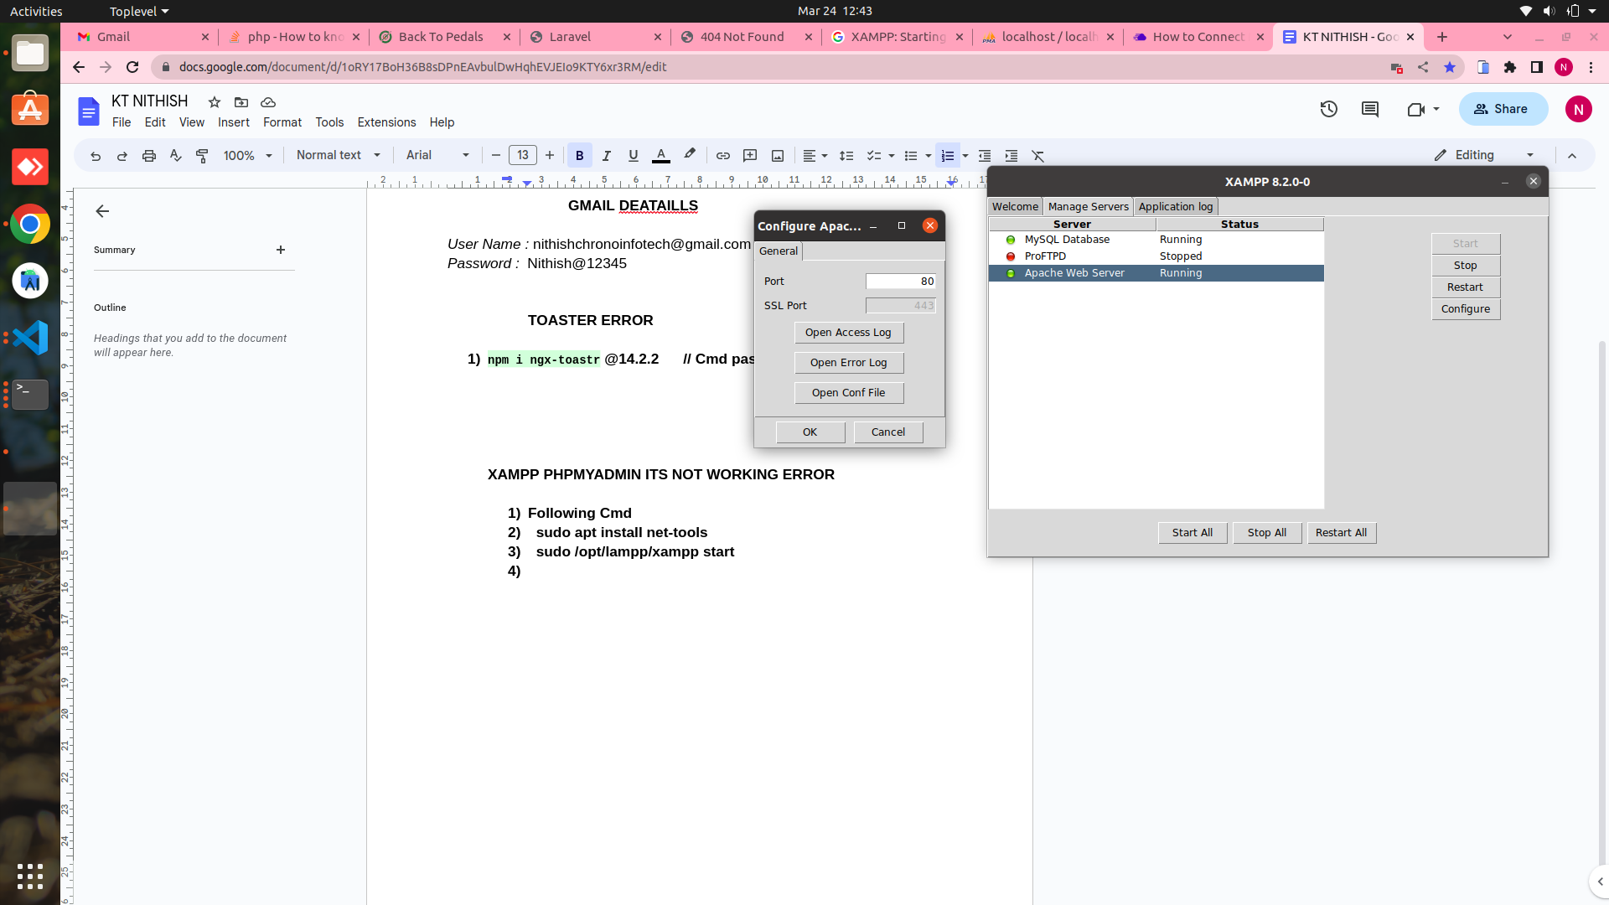
- sudo /opt/lampp/xampp start

Another Method:
- sudo /etc/init.d/mysql stop
2) sudo /etc/init.d/proftpd stop

Then Finally use the Cmd

sudo /opt/lampp/lampp restart

Click a button and then i show a content and then not show a button
[class.d-none]=”showPopupnew”

[ Git Token ]

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

Git pull commands:
- git init
- git remote add origin link
- git remote -v
- git pull origin master
- Nithishchrono
- 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
- token
Git push commands:
- git status
- git remote -v
- git add .
- git status
- git commit -m “meassage”
- git push origin master

Ng build Error :

Firefox ESR
not ios_saf 15.2-15.3
not safari 15.2-15.3

Jquery Error Solve

https://stackoverflow.com/questions/40994719/cannot-find-name-jquery-in-angular2

Scroll Position [ next page pokum pothu top la irunth load aka use akum ] [ import in app routing module ]

imports: [RouterModule.forRoot(routes, {
scrollPositionRestoration: 'enabled'
})],

Instagram feed our website
Instgram feed show our websitet:
https://docs.oceanwp.org/article/487-how-to-get-instagram-access-token
https://github.com/ishithemes/instafeed_website/blob/master/index.html

[ Box shadow: ]

https://getcssscan.com/css-box-shadow-examples

Admin Panel error solving [ Admin panel crate ]

1 ) lazyload error - lazyload ah project la install pnnanum
Use the link - https://www.npmjs.com/package/ng-lazyload-image
Instaall pannathuku apram module la import pannanum -
import { LazyLoadImageModule } from 'ng-lazyload-image';

imports - LazyLoadImageModule

2)

Ng build version mismatch error

https://stackoverflow.com/questions/63764017/an-unhandled-exception-occurred-cannot-read-property-minus-of-undefined

* Owl Carousl arrow removed in ts

navText: [" ", " "],

- Api Issue url localhost:

It happened to me when I replaced in production my .env file with the .env from development. It was failing because it had a different APP_KEY, so I had to generate a new APP_KEY on production.
It was solved after run these commands:
php artisan key:generate
php artisan config:cache
php artisan route:cache
php artisan view:cache
Maybe it isn't necessary to clear the views and routes.
Link:
https://stackoverflow.com/questions/64130722/serializableclosure-error-in-laravel-your-serialized-closure-might-have-been-m

- Angular Upgrade : 13 to 14 and 14 to 14 🎉

- ng update @angular/core@14 @angular/cli@14 --allow-dirty
- ng update @angular/material@14 --allow-dirty --force
- Check angular version : ng version
- ng serve
- node --version : v18.15.0
- nvm install v18.15.0 : npm install cmd
- tsc --version : Version 3.8.3 : sudo apt install node-typescript
- ng update @angular/core@15 @angular/cli@15 --allow-dirty --force
- tsc --version
- Version 3.8.3
- Check angular version
- Ng serve
- npm i ngx-toastr@16.2.0 --force
- Ng serve
- Owl carousel upade

- Laravel Framework Update: 8 to 9
- https://youtu.be/bMVvygYJc0Y Follow the yt ways

- Image Update not working in Laravel 9 ( 8 to 9 )
- composer update
- php artisan cache:clear
- composer remove guzzlehttp/promise
- composer require guzzlehttp/promise

- Xampp Start:
- sudo /opt/lampp/xampp start

- Database laravel error
- Change env -> .env
- php artisan cache:clear
- php artisan config:clear
- php artisan route:clear
- php artisan view:clear
- Sql export pannitu renum panna vendiyathu
- Utf8mb4_0900_ai_ci
- Intha name ku pathila itha replace pannanum utf8mb4_general_ci

- Cludinery mail id
littlekids.chronoinfotech@gmail.com
Chrono@12345

- Web view not display because app module la toaster modul import panama irunthuchi

macbook pro 15– @media screen and (min-width: 1025px) and (max-width: 1280px) {

Testing Razorpayment

https://razorpay.com/docs/payments/payments/test-card-details/

